LAB Assignment No. 1

Lab Assignment – Dataset Creation & Analysis Objective
To learn how to create and upload a dataset in Python, perform basic statistical analysis, and visualize data using graphs.

Tasks Q1: Create a Dataset Manually
- Create a dataset of at least 10 students with the following columns:
o Student_ID, o Name, o Age, o Marks_Math, o Marks_Science.
- Store the dataset in a CSV file named students.csv.
Q2: Upload Dataset in Python
- Use Pandas to load the dataset.
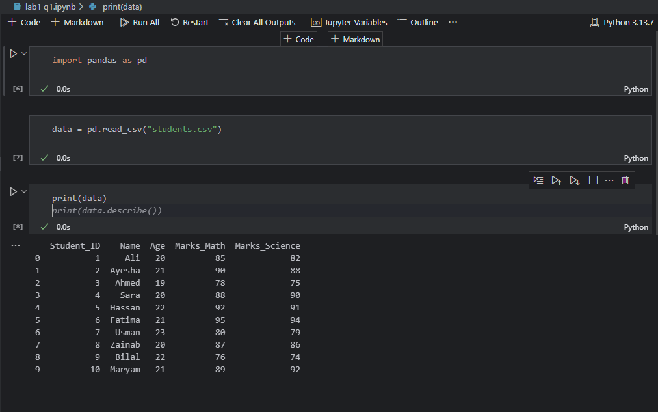

Q3: Observe Dataset Information
Run the following commands and explain the output:
- data.info() → Dataset structure
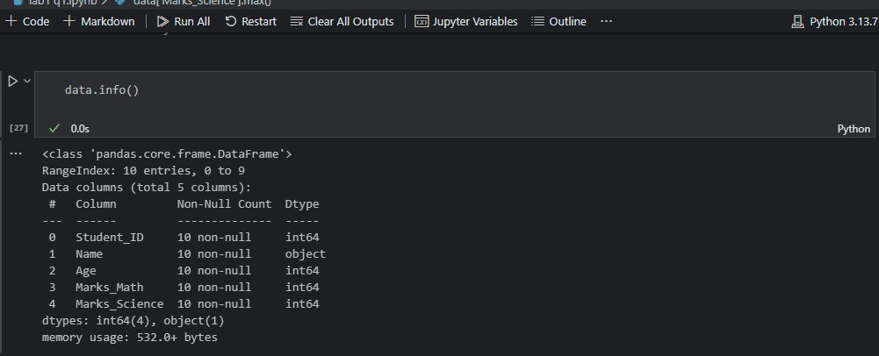
- data.describe() → Summary statistics (mean, std, min, max, etc.)
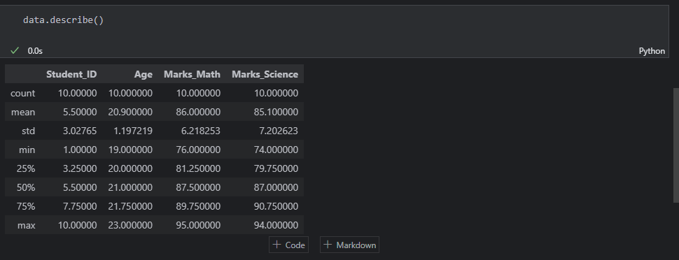
- data['Marks_Math'].mean() → Mean of Math marks
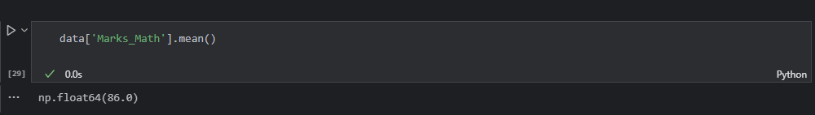
- data['Marks_Science'].max() → Maximum Science marks
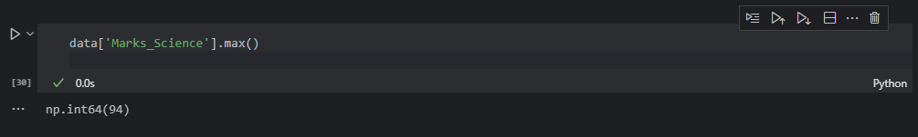

Q4: Perform Some Data Analysis
- Find how many students have Marks_Math > 50.
- Find the student with the highest Science marks.
- Calculate the correlation between Marks_Math and Marks_Science.
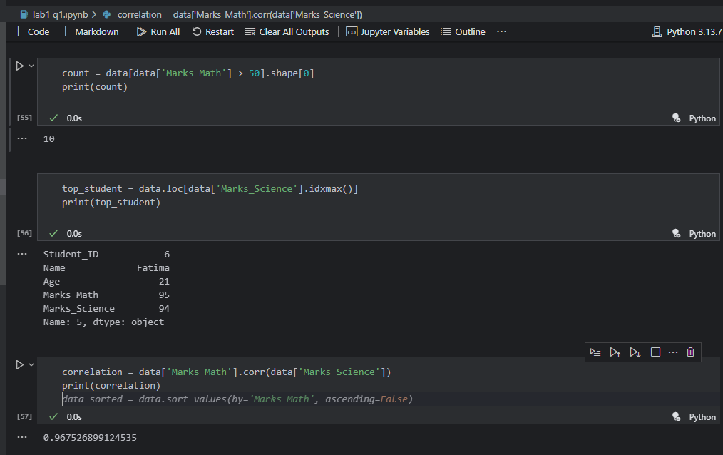

Q5: Data Visualization
Use Matplotlib/Seaborn to create graphs:
- A bar chart of Student_ID vs Marks_Math.
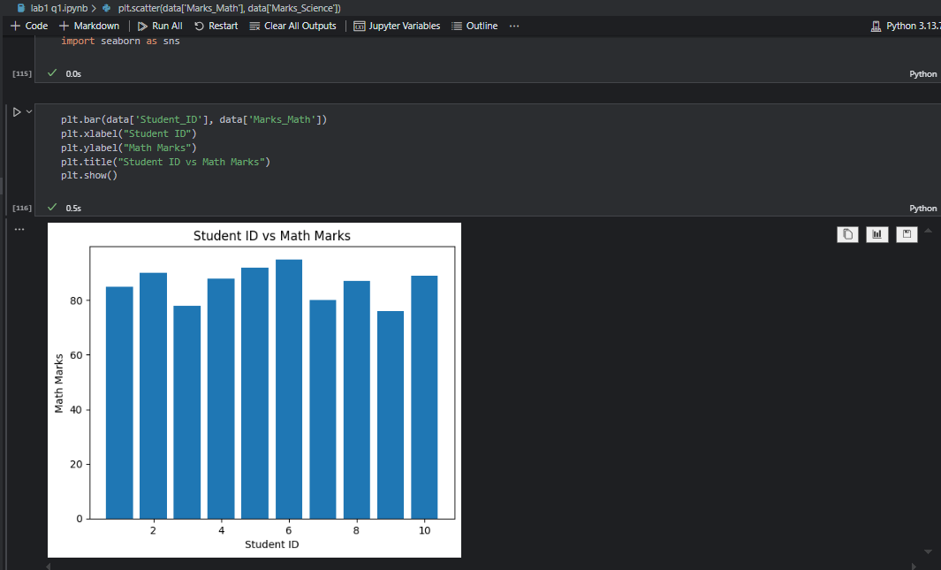
A histogram of Age.
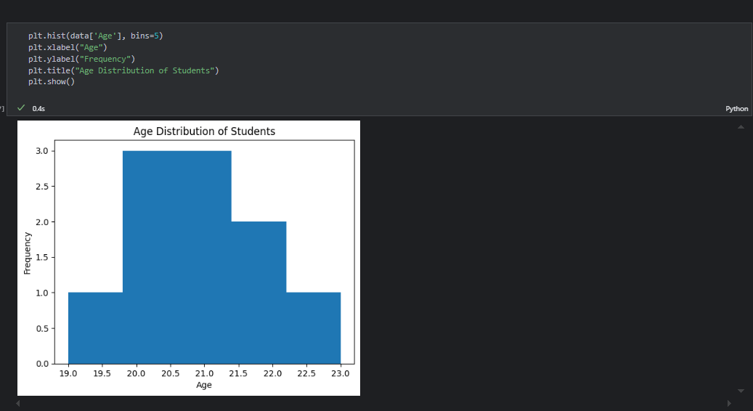
- A scatter plot of Marks_Math vs Marks_Science.
